**Computer Assignment 3A**

**Submitted by**

**Name: Rajiv Lochan Baruah**

**Roll No: 154103093**

|  |  |
| --- | --- |
| **Tabulation of discretised algebraic equation** | |
| Discretised Equation for Solving Stream Function | Ψi,j+1 + Ψi,j-1 + β2Ψi+1,j + β2Ψi-1,j + (∆x)2ωi,j = 2(1+ β2)Ψi,j |
| Discretised Equation for U-V Update | U =(Ψi+1,j - Ψi-1,j )/ (2∆y)  V = - (Ψi,j-1 - Ψi,j+1)/ (2∆x) |
| Discretised Equation for Vorticity BCs update | ωi,0 = -(2/∆x2) (Ψi,1 - Ψi,0)  ωi,M-1 = -(2/∆x2) (Ψi,M-2 - Ψi,M-1)  ωN-1,j = -(2/∆y2) (ΨN-2,j – ΨN-1,j)  ω0,j = -(2/∆y2) (Ψ1,j – Ψ0,j + U∆y) |
| Discretised Equation for Solving for Vorticity | 2(1+ β2) ωi,j = |

|  |  |
| --- | --- |
| Problem Definition | Discretised Domain |
| Screenshot (107).png | Screenshot (60).png |

|  |  |  |
| --- | --- | --- |
| **Tabulation of Results for Re 100 on a 101x101 grid** | | |
| Streamlines | U velocity Contours | V velocity Contours |
| Screenshot (78).png | Screenshot (113).png | Screenshot (112).png |

|  |  |
| --- | --- |
| Tabulation of Validation Results | |
| Y vs. U at horizontal centerline | V vs. X at vertical centerline |
| Uvalid.png | Vvalid.jpg |

|  |  |
| --- | --- |
| Convergence History | |
| Screenshot (115).png | Screenshot (116).png |

**Discussion:**

The code developed for this problem was tested for higher values of Reynolds number and following points were observed:

* Primary vortex at Re=100 is formed near the top right corner of the cavity. This move to the geometric center of the cavity with increase in Re.
* Secondary vortices are formed near the bottom left and right corner of the cavity at Re=100.
* With increase of Re the size of vortex also increases and their centers too move towards the geometric center.
* At Re = 3200, a third vortex is formed at top left corner of the cavity.
* 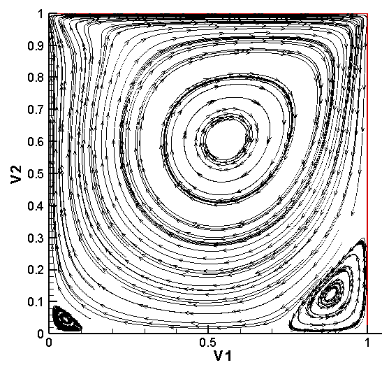Finer grids are required with relaxation scheme to capture the formation of the secondary vortices

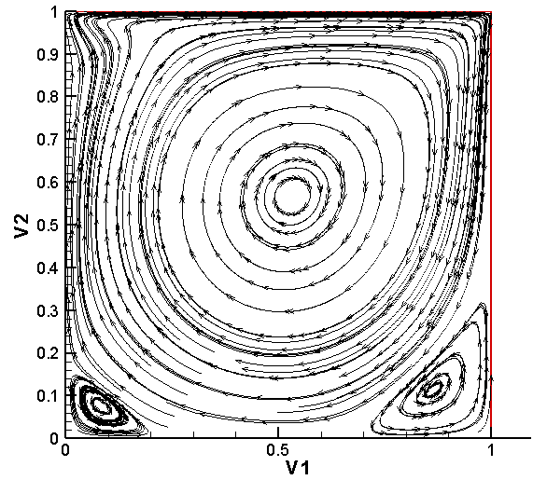

1. (b)

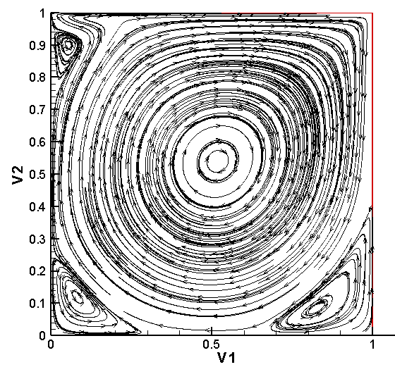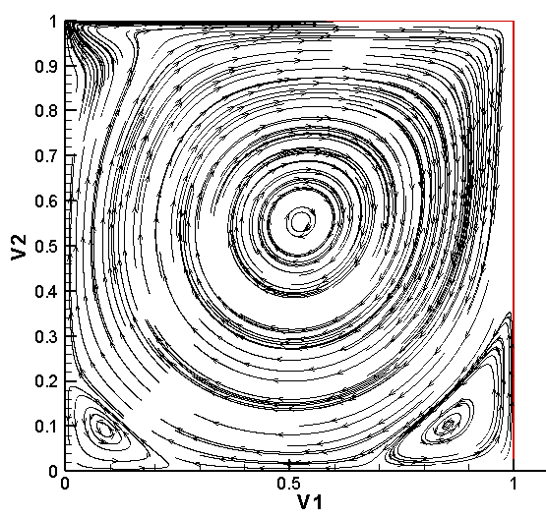

Streamlines at a) Re=400 b) Re=1000 c) Re=1500 and d) Re =3200

(d )

(c )